EWG Biodiversity Day – A Wild Day
12 June 2021
What a great day. Driven by the need to at last actively engage with our 95 members we set out to offer something a little different to our wildlife enthusiasts. The opportunity to meet with members has been severely restricted by the situation with respect to the pandemic.
Our Biodiversity Day was a first attempt to do some practical hands-on activities in 2021. Everything went brilliantly, even the weather! We have had so much positive feedback from those attending the event and for this we thank you.
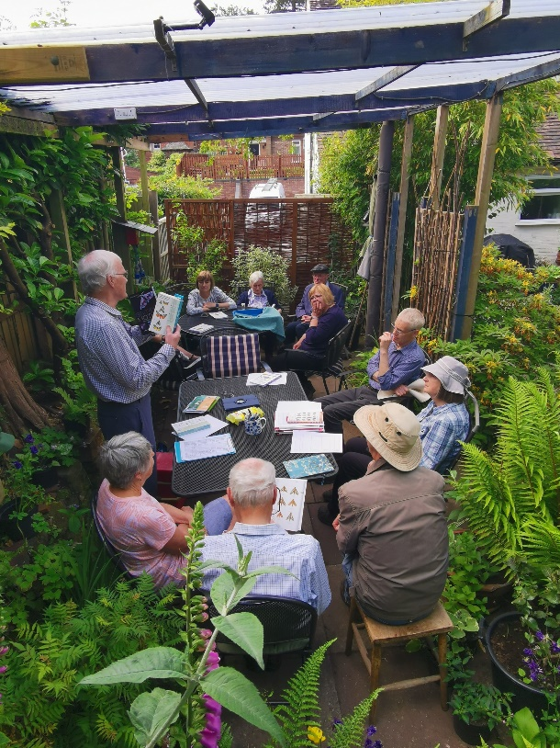
I must take this opportunity to thank all those involved for all their hard work. These events require significance preparation and organisation and I must thank the committee, Jan, Jim and Anne for all their support. Much goes on behind the scenes for these events. It is not just leading activities during the day but putting up gazeboes, arranging chairs and tables, sorting insurance, making sure that orders for equipment are prepared and monitored against budgets, preparing gardens and food, preparing forms and lists, creating guides to bats and mammals, sorting first aid and risk assessments. The list is endless. Without the hard work of our members, supporters and the committee none of this could have taken place. A big thanks to those who made cakes and donated food for the BBQ and a little special thanks to Joe Nunn who seemed to always find the right time to step in and offer help during the day.
Our aim was to engage members in a way that would help them to appreciate the wealth of wildlife that lives in and around the village. During the day we wanted to accumulate data from observations and other activities that would help us to identify types of plants, insects, birds and animals.
Obviously, it was not possible to cover everything, but an exciting programme of dawn chorus, guided bird walk, small mammal trapping, last night’s moths, a wildflower walk and bat detecting went some way towards meeting our objective.
The Dawn Chorus Walk
This event was well attended and we were lucky enough to pick up songs of no less than 28 birds. We were treated to the songs of many common birds including the tuneful tinkling of Goldcrest, not an easy one to pick out. We were also very lucky to pick up the songs of Sedge Warbler, Blackcap and Whitethroat and Chiffchaff.
Small Mammal Survey
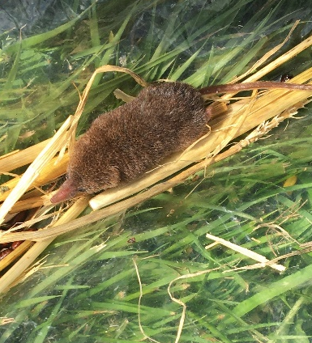
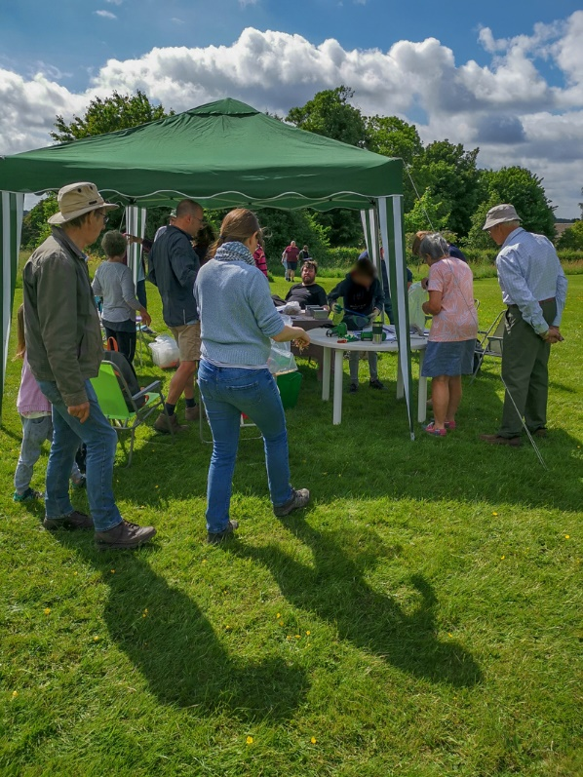
One of the fantastic aspects of the day was the enthusiasm of the participants who were engaged, interested and enthusiastic about every challenge and really got stuck in. A particular highlight was the small mammal survey on the Church Field. Teams of willing participants were dispatched to collect traps bring back whatever live occupants were found in them. Then the job was to identify the mammals, sex and weigh them. The delight on the faces of the younger participants was evident when the occupants of the traps were emptied into large bags to be processed. Processing was not easy. Each group of participants were armed with a guide to small mammals created by Jan Lloyd, a substantial piece of work that took many hours to create. It wasn’t long before one particular mouse leapt out of the bag, spring boarded off the chest of one of the handlers and scooted off at great speed across the field into the long grass. A truly Olympic performance. Although it was difficult to get a confirmed ID on this animal it is likely to be Yellow necked mouse since any experienced mammal handler will tell you that they are difficult to contain and this was certainly true in this instance! This is the first time this animal has been record in Edgmond and hopefully further surveys will confirm this species present on the Church Field. The next exciting discovery was the arrival of a pygmy shrew (above), a tiny, beautiful animal and again to our knowledge never recorded in Edgmond but certainly never recorded on the Church Field in previous surveys.
During the day we caught bank and field voles, wood mouse, pygmy shrew and an unconfirmed yellow necked mouse.
The Guided Bird Walk
This walk took us from the village down to Birch Moor and back. We were lucky enough to have with us Neil Furniss, a member of the local farming community. He was able to put a farming perspective on aspects of the walk and talk about conservation practices that he and other farmers now engage with, on their farms. Highlights from this walk include Cuckoo and four Lapwings. We had excellent views of a pair of skylarks near to the path. The male skylark was singing from the ground, which is unusual. His mate scuttled off across the field suggesting we were too near to their nest. A pair of hares at the back of Harper Adams was another wonderful sight on this warm and sunny day. In total we listed 33 species, all nicely recorded by Joseph Nunn who seem to enjoy the role of chief recorder, though I am not sure about the Golden Eagle!

Breakfast
Breakfast at Paula’s was well received. Thanks to Peter and Joseph Nunn for donating the sausages. Always a pleasure to sit and relax for a while in such a wonderful garden and a chance to socialise for a short while with our members.
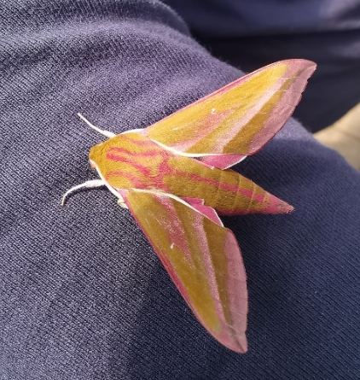
Last Night’s Moths
In the two weeks before the event we had been tutored by Jim and Anne Shaw in the skilled practice of catching and identifying moths. So, Janet and Jim delivered a short course on catching, collecting and then identifying moths. These insects examined were caught live on the previous night from two traps in local gardens and released unharmed at the end of the session.
Jim is an experienced and knowledgeable lepidopterist with many years’ experience. He was able to point out key features to use in the identification process. Participants sat round the table and had first hand experience of identifying the moths they were given. Its hard to believe that amongst those identified were no less than three amazing, beautiful Hawk Moths including the elephant hawk moth (above) and the poplar hawk moth (below)
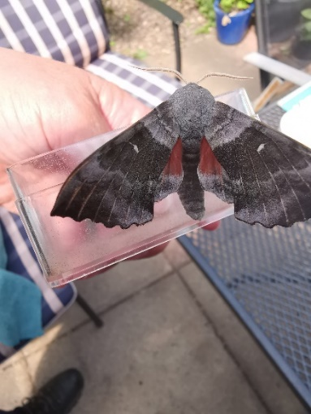
A sexton beetle was one of the insects caught. The beetle has a real symbiotic relationship with the serious gang of mites that ride on its body to remains of dead animals. The mites start processing the food and this makes it easier for the beetle to feed. Then the mites hop back on the beetle and they are off to the next carcass!
From two garden traps 82 species of moth were collected and identified.
Wild flower Walk
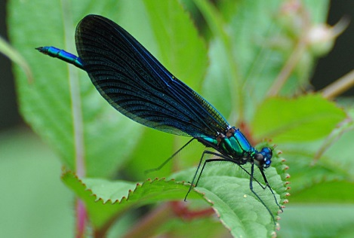
This was a very quintessentially English afternoon activity. Teams of participants set off down a country lane armed with details of a plant treasure hunt. This was a gentle stroll in the afternoon sun to find and identify some of the plants on a village track. “We have never really stopped to look before”, one participant announced. Paula and Jon chaperoned the group to ensure some help was at hand if required. Each team were given a hand lens and a wildflower guide to help in their search and identification activity. The walk finished at the bottom of Pond Lane, where the bridge crosses over the Strine. Here, we looked down on the groups of beautiful blue-green Demoiselle Damselflies that danced over the branched bur reed and a moorhen lucked from deep cover somewhere on the water downstream.
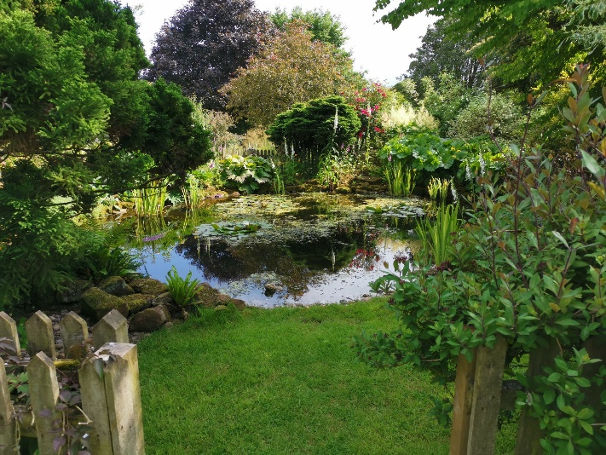
Open Gardens
Paula’s garden (left) and Janet/Jon (below) opened their gardens for members and a steady stream of visitors passed through the gardens during the afternoon. Visitors could sample tea and cake if they liked and sit back for a while, enjoying the relaxing atmosphere, bird song and bees. The two gardens are very different but both gardens have formal borders and both gardens have strong wildlife themes running through them.

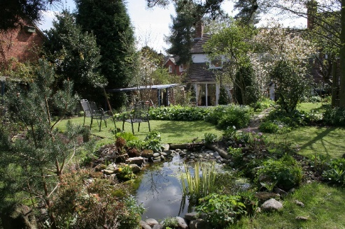
BBQ
Before the last event of the day members enjoyed a BBQ in our back garden. It was a great opportunity for members to meet, chat, and get to know each other.

The Bat Walk
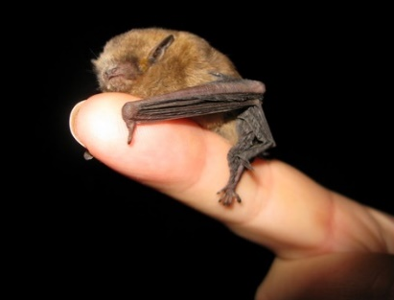
As the light faded, we set off on our final mission. As far as we know, nobody has ever recorded the bat species that live in and around the village. Our intrepid night time recorders set off to the churchyard and then onto Paula’s Garden, to see what they could find. Armed with bat detectors and a guide to Bats prepared by Jan. We might all be familiar with the little Pipistrelle bats that often flit round our gardens and down our lanes on warm nights but what we didn’t know was that there is more than one species of this bat. The Common Pipistrelle and the Soprano Pipistrelle (above). The latter is commonly found hunting over water. This perhaps, explains, why we found this bat hunting over the pond alongside the Common Pipistrelle bat in Paula’s Garden.
We have other areas in and around the village yet to explore and look forward to adding to our list of bat species in the future.
Finally, can we just say what a great way to finish year one of EWG and very big thanks to everyone for making this day so memorable.

