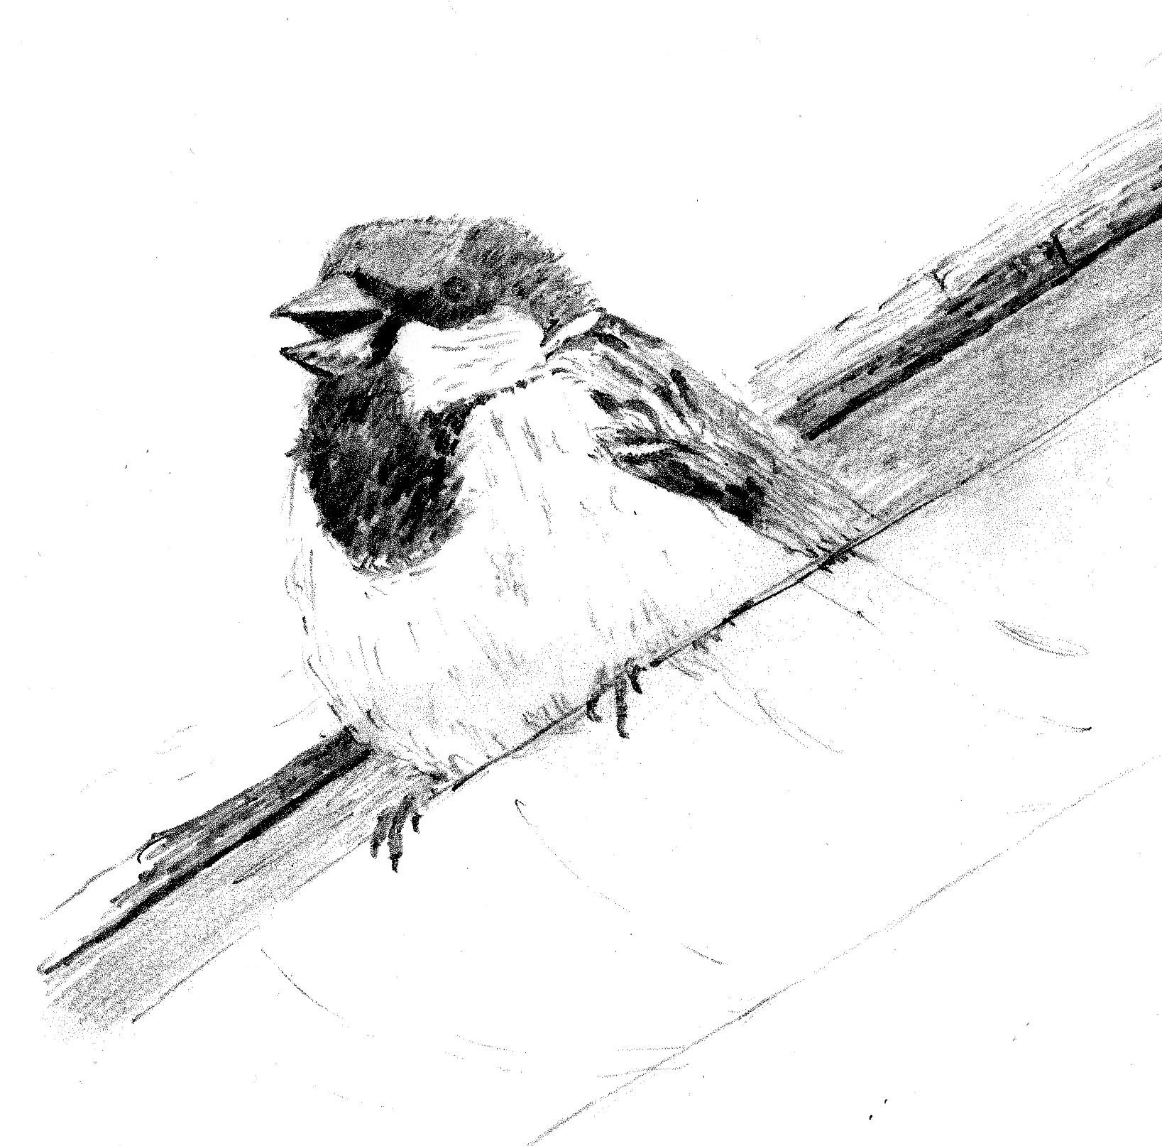
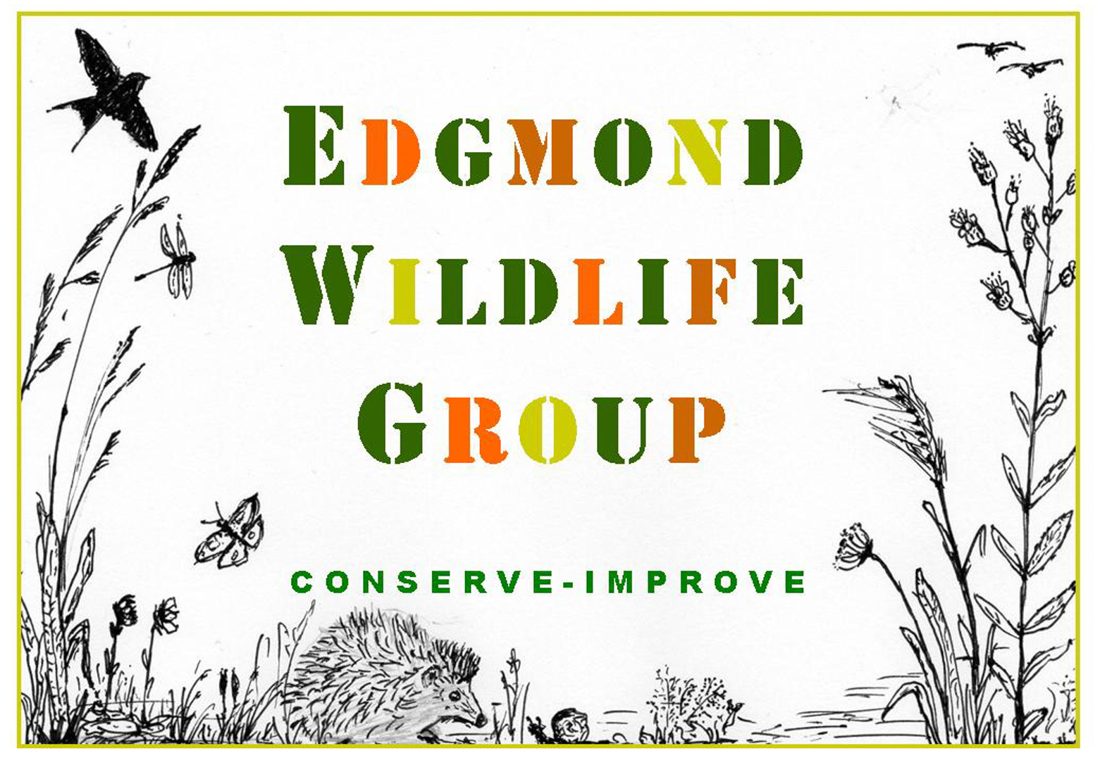
EDGMOND WILDLIFE GROUP
INFORMATION & MEMBERSHIP

EDGMOND WILDLIFE GROUP was formed in the Spring of 2020 when we came together with a shared concern about the crisis facing the natural world. Our first and most important project was to re-imagine the Church Field as a beautiful area in which wildlife could thrive. This project continues to evolve.
WHAT DO WE BELIEVE IN? We believe that we can all help make Edgmond more wildlife friendly. From gardening more sustainably, to hedge & tree planting; from visits to nature reserves to working at the local school; all these activities will help encourage us to be more aware of wildlife on our own patch.
WHAT DO WE DO? We take on practical projects in our local area. We want to inspire others to learn more about wildlife and the environment, and to demonstrate that even small changes can make a big difference. We want everyone to think about nature first!
WHY JOIN US? You will be helping us to continue with our local activities such as maintaining the Church Field, controlling the spread of Himalayan Balsam and taking on other community projects. We regularly call for volunteers to help but it doesn’t matter if you can’t, your membership still matters!
WHAT WILL I GET OUT OF BEING A MEMBER? You will be helping to make Edgmond a more wildlife-friendly place. You could join work parties & occasional ‘behind the scenes’ trips to local Nature Reserves, or join guided walks. You can share your wildlife photographs or sightings. You will receive occasional newsletters and an Annual Report. You could even join the Committee!
HOW CAN I FIND OUT MORE? We communicate directly with you via email. We also have a website, a Facebook Page and a presence on the social media platform NextdoorEdgmond.
https://www.edgmondwildlife.com/
https://www.facebook.com/groups/edgmondwildlifegroup
https://nextdoor.co.uk/g/805mh3pvh/?init_source=search&query=Edgmond%20wildlife%20group
WHAT TYPE OF MEMBERSHIP IS AVAILABLE? FAMILY membership is £10 p.a. for one or more adults with any children at the same address. SINGLE adult membership is £8 p.a. STUDENT membership is £4 p.a.
Our membership year begins on June 1st. If you join between Jan and May, your payment will cover those extra months as a bonus. If you join between June and Dec your membership will still begin on the previous 1st June.

WHAT NEXT? Please fill out the form below. All personal information will be held in accordance with current data protection guidelines. We accept cash or cheque but prefer a bank transfer. A Standing Order is great!

For bank transfers & Standing Orders your FULL NAME is the reference. Lloyds Bank: 23648460 30-99-50

MEMBERSHIP TYPE: | PAYMENT METHOD:
NAME(S) OF ADULT(S):

ADDRESS & POSTCODE:

EMAIL ADDRESS(ES):

PREFERRED PHONE NUMBER:

RETURN by post, hand, or email to our TREASURER Simon: 3 Turners Lane, Edgmond, TF10 8JT
Email: selord37@gmail.com.

